**Article Title Article Title Article Title Article Title Article Title Article Title Article Title Article Title Article Title Article Title Article Title Article Title\***

Author1 Name Surname[1], Author2 Name Surname[2], …

**Abstract:** The Abstract of the manuscript should explain to the general reader why the research was done, what was found, and why the results are important. The abstract should be max 200 words and includes the purpose and scope of the study, research method, and result and contain no references. The abstract is not divided into sub-headings. The Abstract of the manuscript should explain to the general reader why the research was done, what was found, and why the results are important. The abstract should be max 200 words and includes the purpose and scope of the study, research method, and result and contain no references. The abstract is not divided into sub-headings. The Abstract of the manuscript should explain to the general reader why the research was done, what was found, and why the results are important. The abstract should be max 200 words and includes the purpose and scope of the study, research method, and result and contain no references. The abstract is not divided into sub-headings. The Abstract of the manuscript should explain to the general reader why the research was done, what was found, and why the results are important. The abstract should be max 200 words and includes the purpose and scope of the study, research method, and result and contain no references.

**Keywords:**  Minimum 3, maximum 5 keywords that reflect the whole study should be identified.

**1. Introduction**

The main text of the manuscript includes literature, method, findings, results, and discussion, conclusion, and implications. It can be divided into sub-headings. Max. three levels of subheadings may be used if warranted; please distinguish them clearly. Subsections should be numbered 1.1 (then 1.1.1, 1.1.2, ...), 1.2, etc. The manuscript should start with a brief introduction describing the paper’s importance and significance. The introduction should provide readers with the background information needed to understand the study and the reasons why the authors conducted its experiments. Technical and vocational terms, symbols, abbreviations, and acronyms should be defined the first time they are used.

The main text of the manuscript should ideally be no more than 6000 words (not including Abstract, References, Tables, and figure legends). The main text of manuscripts should be typewritten using Calibri font (11-point size) and single-spaced on an A-4 size paper with 1 cm margins each side. 6 nk spaces should be left between the headings and the paragraphs.

All tables and figures should be cited in numerical order. Table and Figures of manuscripts should be typewritten using Calibri font (9-point size) and single-spaced. All figures include relevant captions and begin each figure caption with a label, “Figure 1.”, below the figure. All tables include a title which begins each table caption with a label “Table 1.” above the table, description, footnote, and source are below the table. Tables and Figures should present new information rather than duplicating what is in the text. The figures and tables should be readable and clear.

The journal uses the APA-American Psychological Association’s format (6th edition) for bibliographic citations. Explanatory material will be presented in endnotes. See APA 06 for information about APA. All references mentioned in the Reference List are cited in the text. References to unpublished materials are not allowed to substantiate significant conclusions of the paper. References should be typewritten using Calibri font (9-point size) and single-spaced.

* 1. **First Subtitle of Study**

Information about this title.

***1.1.1. Second level Subtitles of Study***

Information about this title. Tables are to be centered. Tables must be numbered sequentially, with their title centered above the table (Table 1).

**Table 1.** The caption for a figure must follow the figure

|  |  |  |  |
| --- | --- | --- | --- |
| **Variables** |  | **f** | **%** |
| Type of School | Primary | 109 | 29.5 |
| Secondary | 171 | 46.2 |
| High | 90 | 24.3 |
| Gender | Female | 191 | 51.6 |
| Male | 179 | 48.4 |
| **Total** | | **370** | **100** |

Similarly, figures are to be centered. Figures must be numbered sequentially, with their title centered below the figure (Fig. 1).

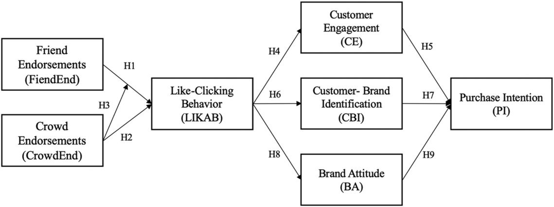

**Figure 1.** The caption for a figure must follow the figure

**2. Method**

The method section is to provide a detailed description of how the study was conducted, and include scales, data gathered, and analysis types.

**3. Findings**

The findings of the research should be included in a separate section of the article, as it is the only section that contains data and results of the analysis.

**4. Results:**

In this section, only findings should be described without discussion of their significance. Results are typically presented with no duplication of information in the text.

**5. Discussion**

The largest part of interpreting and discussing the research findings should be reserved for this section. Authors compare or contrast the results with findings from previous and similar studies.

**6. References**

Blease, C., & Kirsch, I. (2016). The placebo effect and psychotherapy: Implications for theory, research, and practice. *Psychology of Consciousness: Theory, Research, and Practice, 3(2),* 105-107. <http://dx.doi.org/10.1037/cns0000094>

Çoklar, A. N., Efilti, E., & Şahin, Y. L. (2019). Technostress as a factor affecting the use of technology by beginning teachers. *In Handbook of Research on Faculty Development for Digital Teaching and Learning (pp. 460-480).* IGI Global.

Kabakci Yurdakul, I., & Çoklar, A. N. (2014). Modeling preservice teachers’ TPACK competencies based on ICT usage. *Journal of Computer Assisted Learning*, *30*(4), 363-376. <https://doi.org/10.1111/jcal.12049>

|  |
| --- |
| **Recommending Citing:**  Author1 Surname, Author Surname2,… (2020). Article Title. *Journal of Innovative Education Studies – JIES, Volume(Number), page numbers,* doi:http:/doi.org….***(please do not write anything in this part)*** |

***Conflict of Interest***

Please write if there is any conflict of interest or "it has been reported by the authors that there is no conflict of interest."

**Acknowledgements**

If it is a supported project, you can provide the support information (project number and institution information) in this section. In addition, if there is a special explanation you want to add, you can write in this section. ***(This section is optional)***

***ORCID***

Write the ORCID numbers of the authors in the order as follows.

Author 1 Name Surname [](http://orcid.org/0000-0002-2871-8589) http://orcid.org/0000-0000-0000-0000

Author 2 Name Surname [](http://orcid.org/0000-0002-2871-8589) http://orcid.org/0000-0000-0000-0000

**…**

1. * Article information - thesis information, congress paper etc. (if any)

   Department, University, City, Country and email information of author 1.
2. **Corresponding Author:** Department, University, City, Country and email information of author 2.

   …